Vanguard’s proprietary portfolio construction models are the quantitative foundation of Vanguard’s portfolio construction framework. Two models/optimizers used in tandem are the VCMM, our simulation engine for asset return and risk forecasts, and the VAAM, our portfolio optimization engine.

VCMM generates Asset return distributions, not just asset return point forecasts. Portfolio

construction uses the full range of VCMM statistical return distributions, including return volatility and correlations, in addition to the long-term average (or expected) returns. Several key features are as follows: The Vanguard Capital Markets Model (VCMM) employs a probabilistic framework, focusing on medium- to long-term economic and market valuation forecasting, as short-term forecasting is less reliable. It accounts for the sensitivity of medium-term return projections to initial conditions, like price-earnings ratios and interest rates. The two sets of VCMM forecasts generally used in their portfolios are long-term

forecasts (30 years or more), and medium-term forecasts (typically 10 years). However, there is a key issue that Medium-term asset return forecasts (i.e., the full distribution of returns) can change with the market environment, such as periods of extreme equity market valuations, large and persistent shifts in interest rates, or high-inflation regimes, to name a few market drivers. An illustrative plot is described as below: 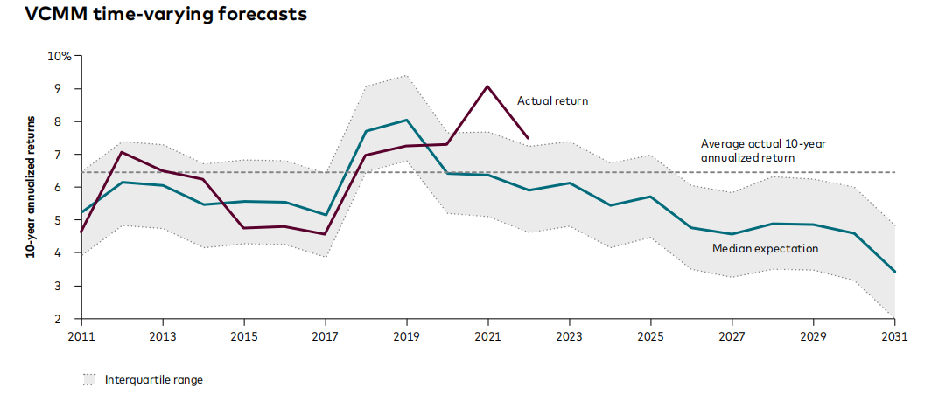

For VAAM, it uses a utility-driven representation of investor outcomes to maximize investors’ chances of achieving their financial goals, conditional on their risk tolerance. A range of investments is then selected, including various asset classes, factors, and active products. The VCMM provides expected asset return distributions, including volatility and correlations, as inputs for these investments. Finally, the VAAM uses these inputs to balance the potential rewards against the risks of each investment, guided by the investor's risk tolerance through utility-driven optimization.

